**Splunk**

After installation to start splunk on your system you by following step

cd /opt/splunk/bin

sudo ./splunk start

After running this command it will ask you for setting username and password

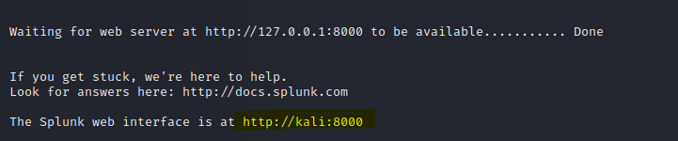

Open this interface on your browser

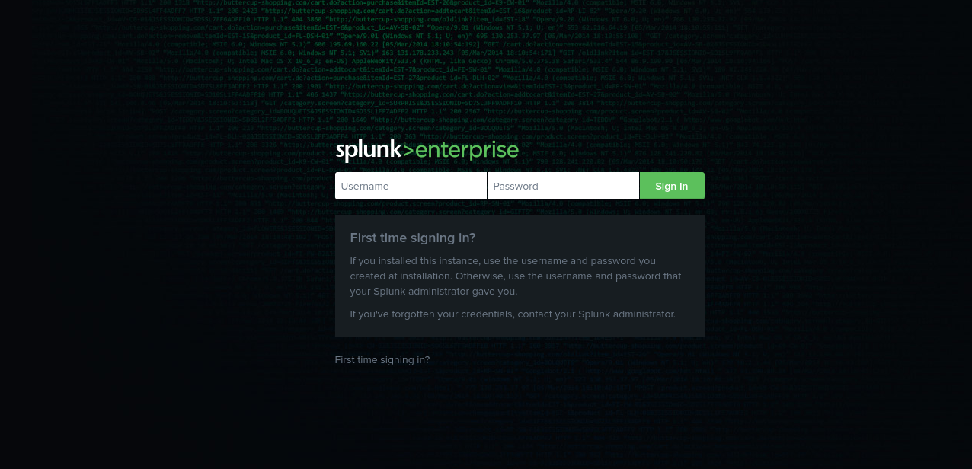

Enter the username and password

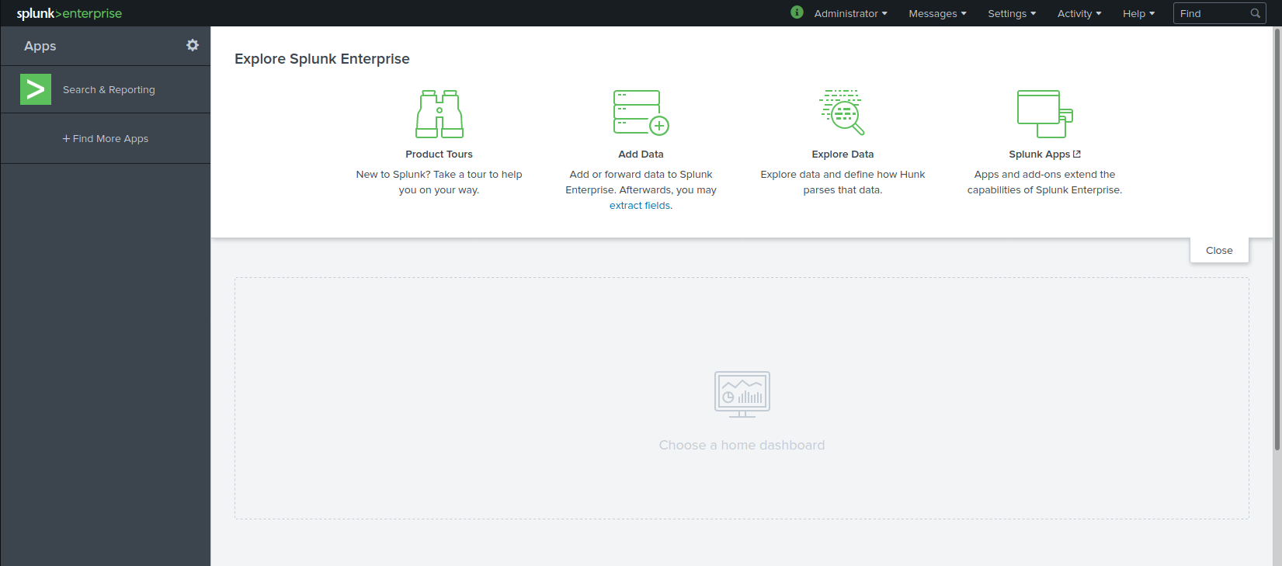

Let create user

Got to Setting->User and authentication->Users->New User. Add a new user and fill the required information and create a Powe user which have less privilege then administrator account

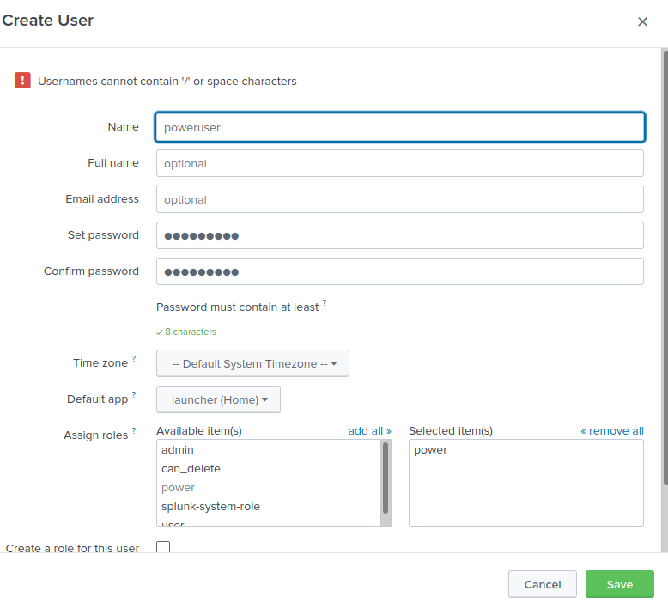

Now let’s proceed for data ingestion so we need some data you can have from [splk.it/f1data](http://splk.it/f1data)

Now go to home page and Click on **add data** now click on upload.And upload the access_30DAY.log file from tmp folder in zip by clicking on source

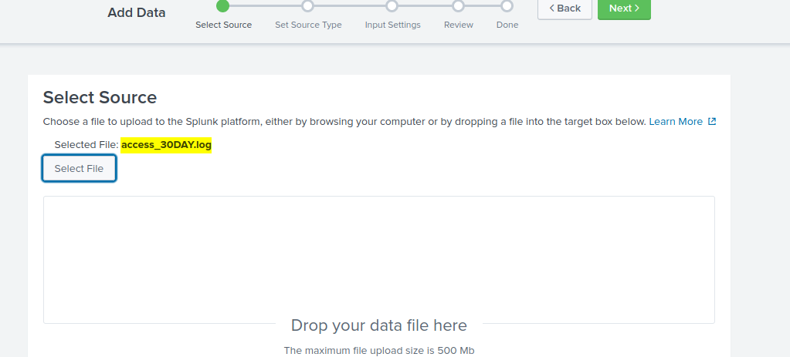

Now click on Next and check your source type

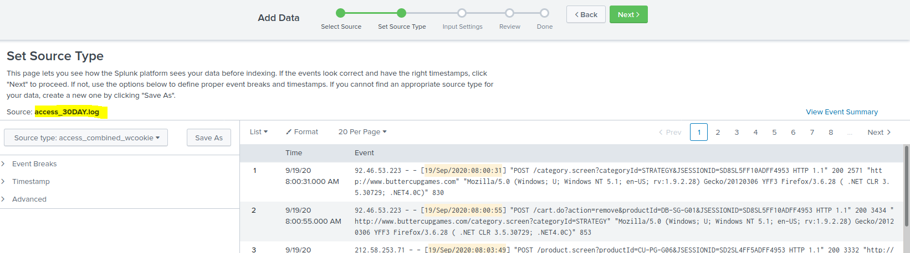

And click on next again and window you will add host field name

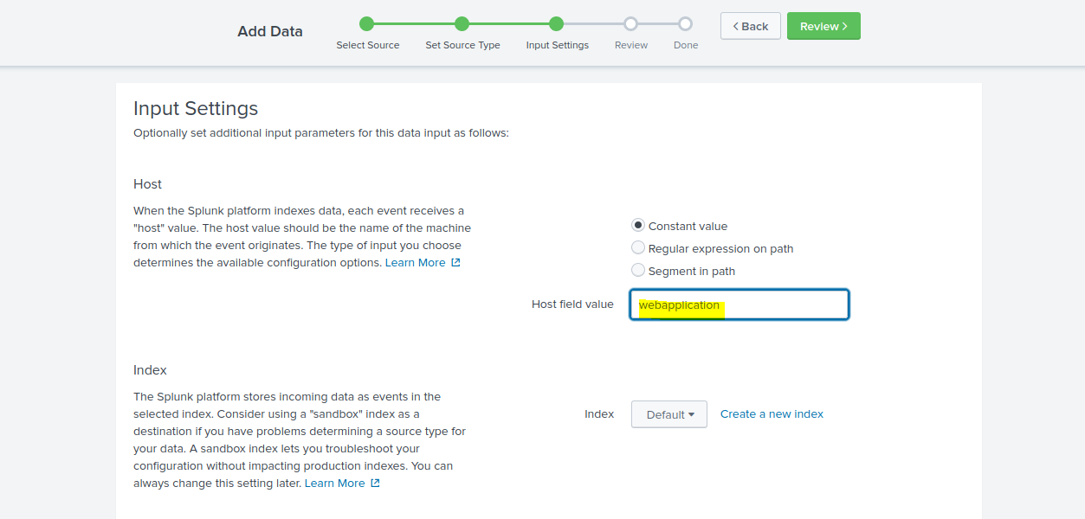

Click on **review** and review tab will appear

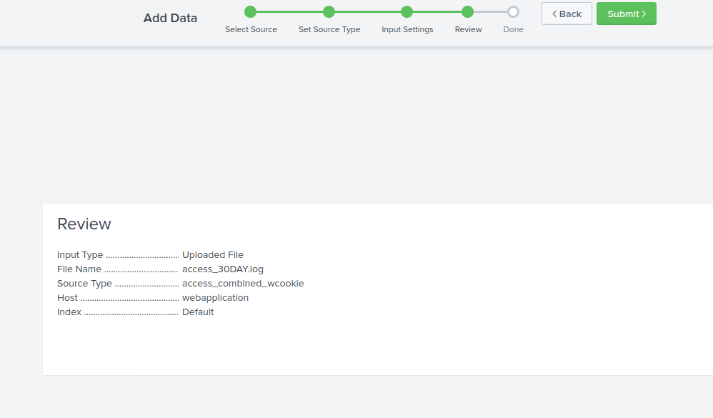

Now click on submit and the file processing will start

Now add linux_s_30DAY.log for this select **source type -> Operating system->linux->secure_type**

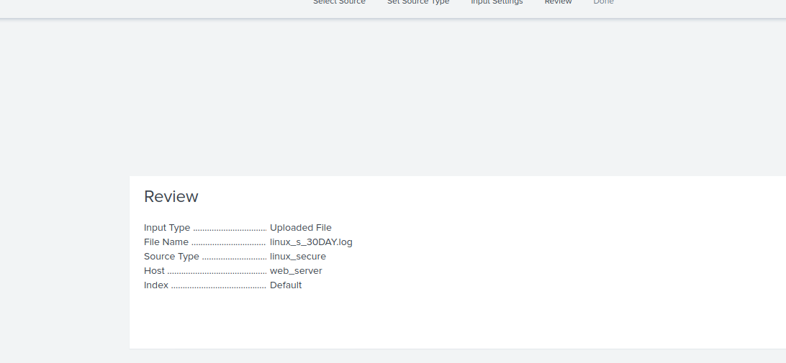

Now click on submit

Now upload **db_audit_30DAY.csv** and click on **Save as** and fill the details as given below

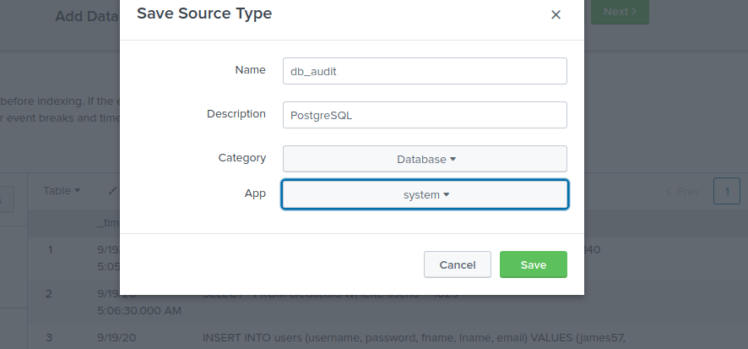

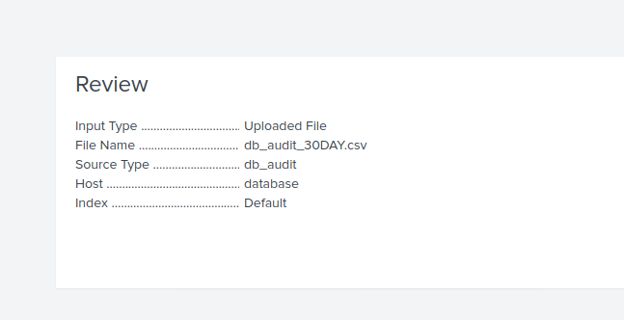

Now logout from Adminstrator and lo in as Power user

Click on searching and reporting

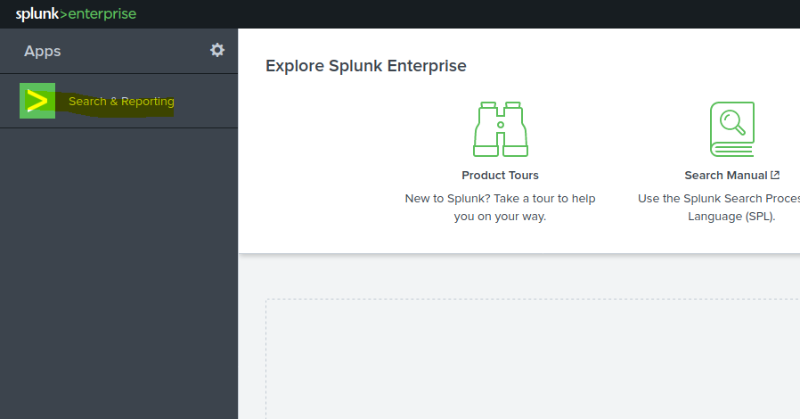

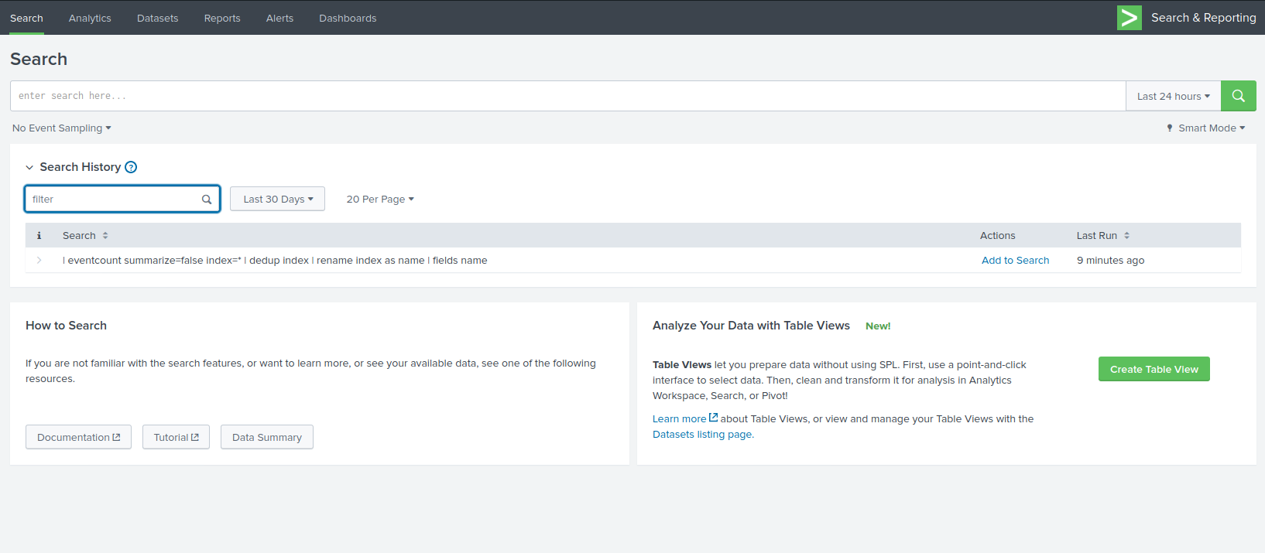

index=main sourcetype=access_combined_wcookie action=purchase status=200 file=success.do | fields action, JSESSIONID, status

index=main sourcetype=access_combined_wcookie action=purchase status=200 file=success.do | table action, JSESSIONID, status

index=main sourcetype=access_combined_wcookie action=purchase status=200 file=success.do | table JSESSIONID, action, status | sort UserSessions

To remove duplicate values

index=main sourcetype=access_combined_wcookie action=purchase status=200 file=success.do | table JSESSIONID, action, status | dedup JSESSIONID | rename JSESSIONID as UserSessions | sort UserSessions

6

index=main sourcetype=access_combined_wcookie action=purchase status=200 file=success.do | table JSESSIONID, action, status | dedup JSESSIONID | rename JSESSIONID as UserSessions | sort UserSessions | top productid limit=5

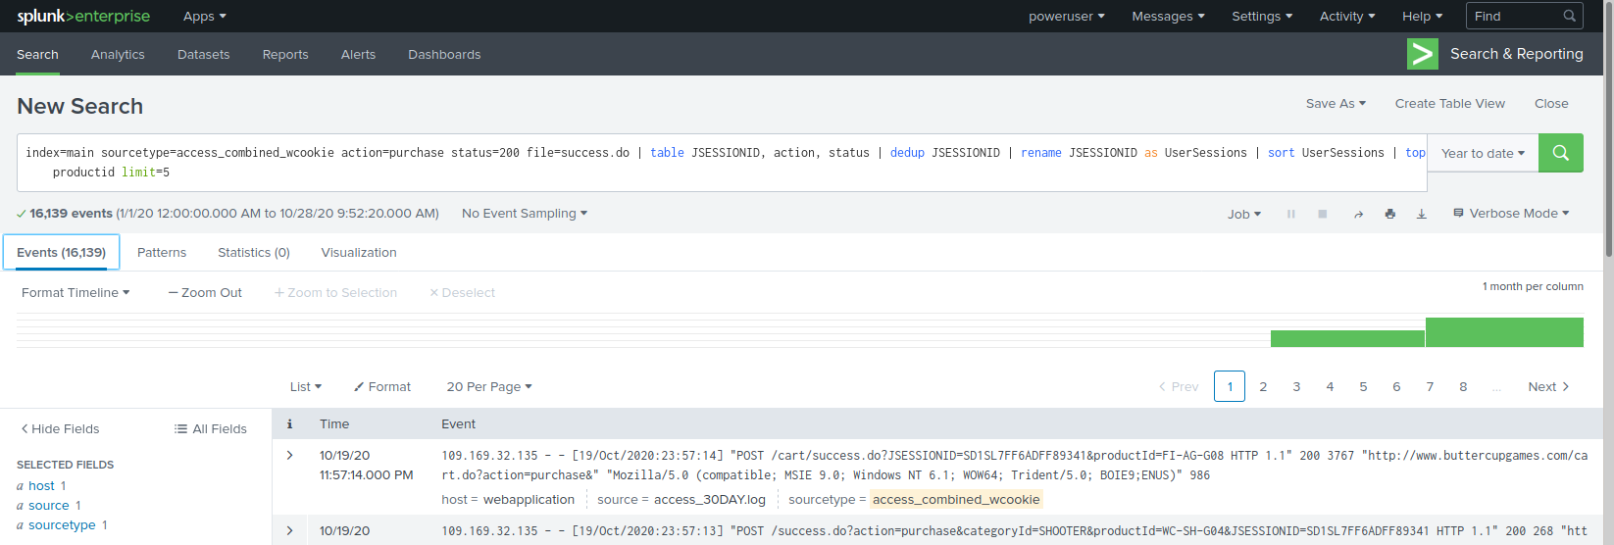

to get a famous product

index=main sourcetype=access_combined_wcookie action=purchase status=200 file=[success.do](http://success.do/) |top productId limit=5 | fields productId countv

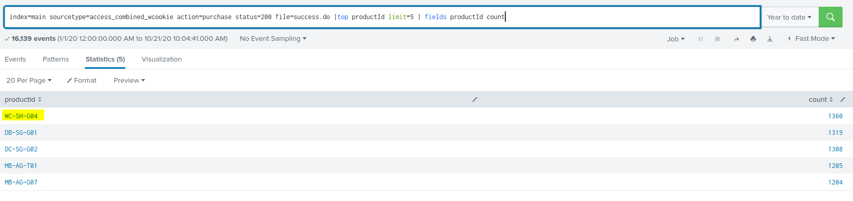

7

index=main sourcetype=access_combined_wcookie status=200 | rare file

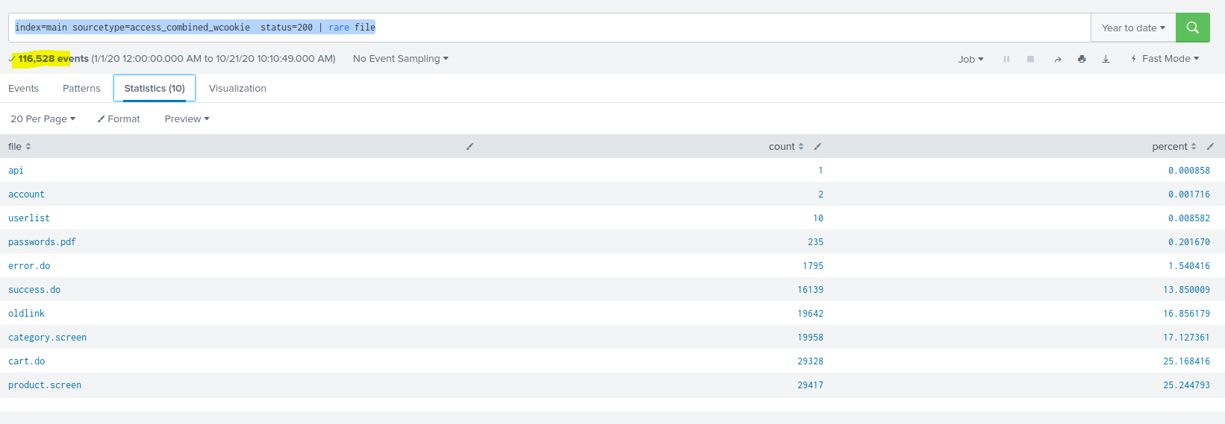

Sorting by date_month

index=main sourcetype=access_combined_wcookie status=200 | rare file | sort date_month

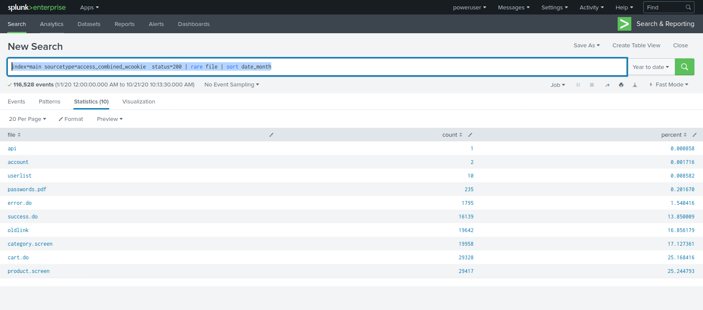

Least access file

index=main sourcetype=access_combined_wcookie status=200 | rare file | sort date_month

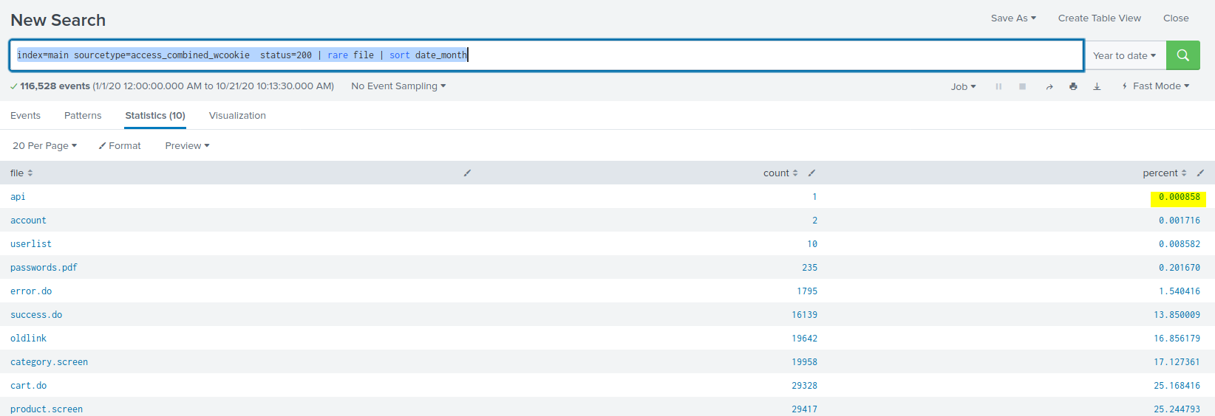

8

index=main sourcetype=access_combined_wcookie file=success.do OR file=cart.do status=200 | stats

count by file

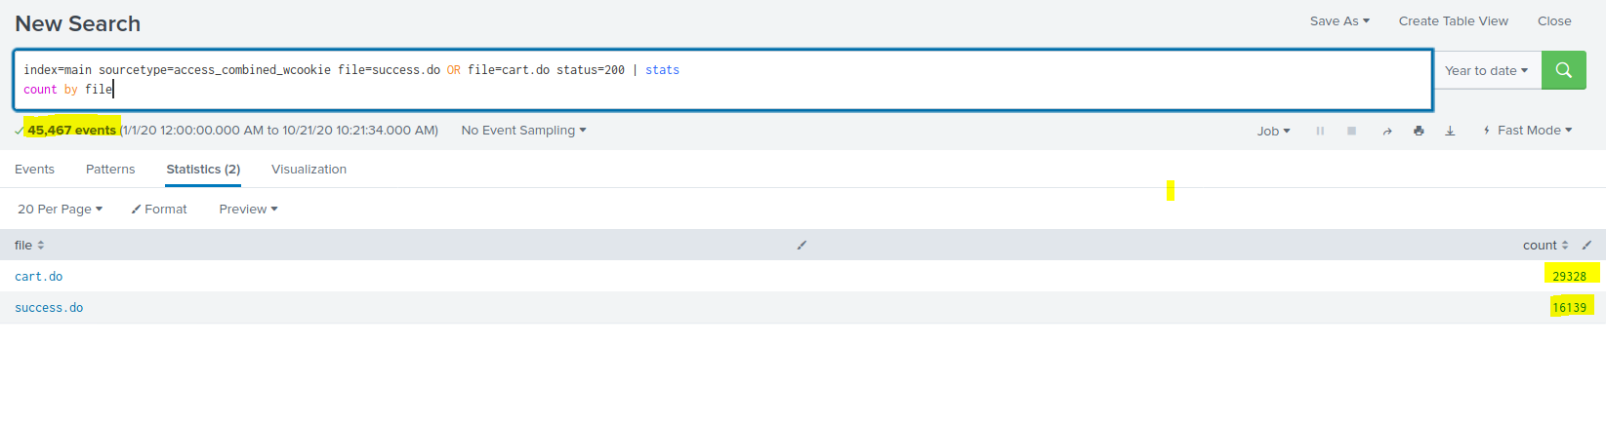

Module VII: CREATING REPORTS AND DASHBOARDS

index=main sourcetype=access_combined_wcookie status=403 | stats

count as attempts by clientip

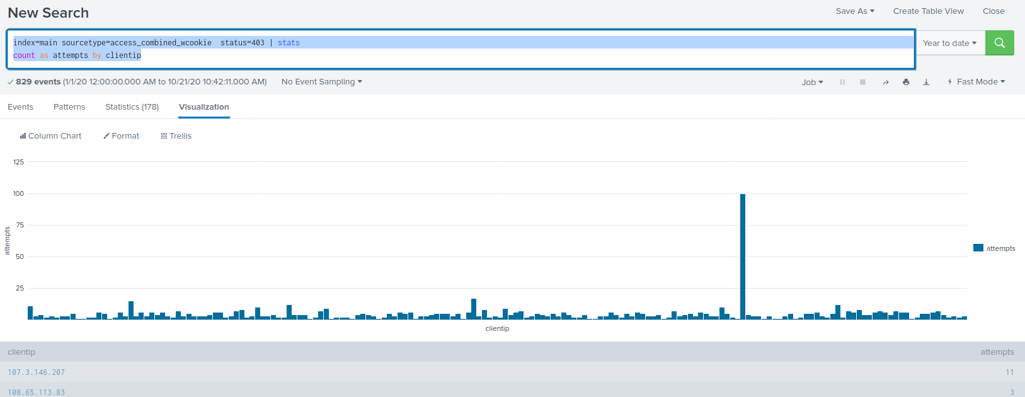

index=main sourcetype=access_combined_wcookie status=200 file=success.do | stats

count as productId

